Question 1
Discuss two major situations where heuristic strategies are used in AI problem solvers.

The first situation is when the problem may be ambiguous or the data available may not provide a clear answer.
For example, in medical diagnosis, in order to make the most likely diagnosis and formulate a treatment plan for a given set of symptoms, doctors use heuristics.
Another example is because visual scenes are often difficult to interpret, vision systems use heuristics to choose the most likely interpretation of the scene.

The second situation is when there may be a clear solution to a problem, but the computational costs of finding it may be too high.
For example, in many problems such as chess ,state space grows exponentially or factorially as the depth of search increases. Heuristics helps in searching the most “promising path” in the state space by not considering and eliminating unpromising states and their descendants.

Question 2

For this question, you should write a short report that explains how your program works and give some execution examples.
Given a graph G and two nodes A and Z in G, write a program in Prolog or Lisp that finds an acyclic path P between A and Z. The path should be represented as an ordered list of nodes from the start node to the goal node. Since the path must be acyclic, a node can appear in the path only once.

The graph(g) predicate is the graph.
The 2 nodes predicate -> node A and node Z.
The start of the graph is the node A and the goal node of the graph is the node Z.
Since it is a graph, there is an edge between A to Z and as the graph consists of only two nodes as mentioned in the question, the path from start to goal will be A to Z. The predicate to get from start to goal is “path(X, Y, [X,Y]) :- edge(X, Y).” I have included an image to give some execution examples (in prolog).
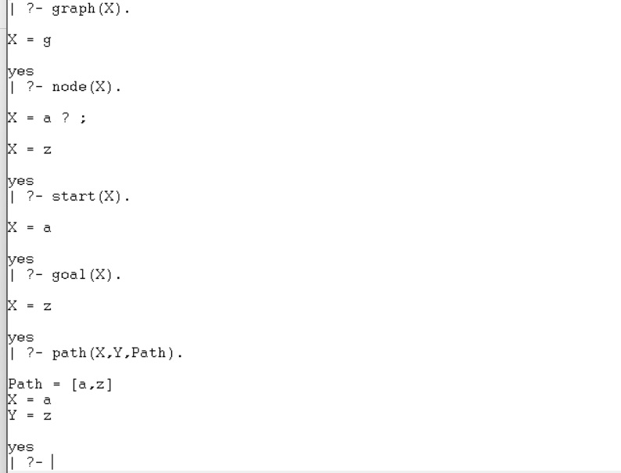

Question 3

For this question, you should write a short report that explains how your program works and give some execution examples.
Write a program in Prolog or Lisp that given two nodes X and Y in the graph above will find the minimum-cost path from node X to node Y and display the found path and its cost. All data about the graph should be declared in the program.
Example: the minimum path between a and d is [a,b,c,d] with cost = 6.

First, I stored the edges and the cost of each of them in a list as a global variable to be used in my main recursive function.
I started my algorithm by creating a function called findMin which takes 2 parameters, the starting node and the ending node.
The function findMin will first check if we have a starting node or not. If not, it will store the starting node in a global variable.
After that, it will call the function nextNode which will return the next node we need to go to which has the lowest value. As we get the next nodes with the lowest cost, we add the cost of their path to a global variable named totalCost and also store the path nodes in the global variable.
Then, we will compare to check if the next node is actually the end node. If it is not, we recursively call the function findMin and give a new start node which will now be the next node and the same end node. We do that until we have reached the end node that we are searching for.
When we reach the end node, we will print the total cost it took to reach the end node and also print the path, from the global variable ,that it took to reach there. Here are some execution examples (in lisp):
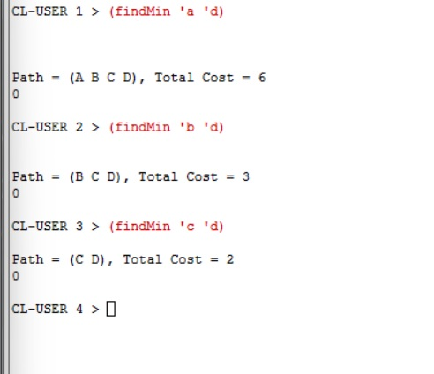

Question 4

For this question, you should write a short report that explains how your program works and give some execution examples.
Write a Prolog/Lisp program that teaches children how to pronounce multisyllable words by dividing them into syllables.

To compare and see which alphabet is a vowel or consonant, I stored vowels and consonants as two different lists at the start of my program.

I then defined a function called printSyllables taking only one parameter which is the word that will be divided into syllables.

The function printSyllables will then get the first char of the word using “car” and call a function which will check if that char is a vowel or consonant. If it is a vowel it will increase a vowelCount and if it is a consonant it will increase a consonantCount. Regardless of what it is, that char will be pushed in a list. Now, if the countVowel is 2 or if the countCons is 2 it will push a hyphen char “-” and then it will reset both countVowel and countConsonant. Finally return to function printSyllables.

Then the function printSyllables calls itself by giving the cdr of the word and repeating the process until the word is nil.

The function printSyllables works like this:

printSyllables( “analog”) ⇒ printSyllables(“nalog”) ⇒ printSyllables(“alog”) ⇒ .. ⇒ printSyllables(nil)

Some execution examples (in lisp):
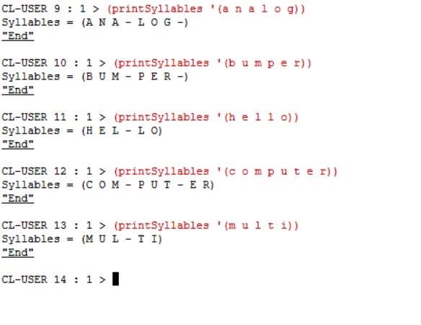

Codes for question 2:

Graph in prolog

graph(g).

node(a).
node(z).

start(a).
goal(z).

edge(a,z).

path(X, Y, [X,Y]) :- edge(X, Y).

Codes for question3:

FindMin in Lisp

;the graph nodes
(defparameter *list* '( (a b 3) (b c 1) (c d 2) (b d 5) (d b 2)) )
;the list to store the path
(defparameter *node* '())
;the var to store the total cost of the path
(defparameter totalCost 0)

;function to find lowest path in a graph
(defun findMin (start end)

;at first we push starting node in the list *node*
(if (equal *node* nil)
(push start *node*)
)
;find the next node and assign to nextnode variable
(setq *nextNode* (getNext start))

;(format t "Next node = ~a ~%" (cadr *nextNode*))
(push (cadr *nextNode*) *node*)
;add all cost we get as we will always get the minimum cost
(setq totalCost (+ totalCost (caddr *nextNode*)))

(terpri)

;if we reached end node we print the path and the total cost
;else we recurse until we reached end node
(if (equal (cadr *nextnode*) end)
(format t "Path = ~a, Total Cost = ~a~%"(reverse *node*) totalCost)
(findMin (cadr *nextNode*) end)
)
(setq *node* '())
(setq totalCost 0)
(terpri)
)

;function to find the next node with the lowest value
(defun getNext(node)

(setq cost nil)
(setq checkCost nil)

;loop for each node in the list
(loop for x in *list* do
;check to see if we reached the node that we are searching
(if (equal node (car x))
(progn
(if (equal cost nil) ;at first at whatever value we get
(progn
(setq cost x)
(setq checkCost (caddr x))
)
)

;second time we find a value we compare and get the lowest value and store whichever is the lowest
(if (not(equal cost nil))
(progn

(if (> checkCost (caddr x))
(progn

(setq checkCost (caddr x))
(setq cost x)
)
)
)
)
)
)
)
;return the lowest next value node
(return-from getNext cost)
)

Codes for question 4:

Syllables in Lisp:

(defparameter *vowelList* '(a e i o u) )
(defparameter countVowel 0)
(defparameter countCons 0)
(defparameter *syllables* '())

(defun printSyllables (word)
(setq first (car word))
(setq second (cdr word))

(incCount first)

(if (not (equal second nil))
(progn
(printSyllables second)
)
(format t "Syllables = ~a ~%" (reverse *syllables*))
)
(setq countVowel 0)
(setq countCons 0)
(setq *syllables* '())
(return-from printSyllables "End")
)

(defun incCount (alpha)

(if (find alpha *vowelList*)
(progn
(incf countVowel)
(if (not(= countVowel 2))
(push alpha *syllables*)
(progn
(setq countVowel 0)
(setq countCons 0)
(push alpha *syllables*)
(push '- *syllables*)
)
)
)
(progn

(incf countCons)
(if (not (= countCons 2))
(push alpha *syllables*)
(progn
(setq countCons 0)
(setq countVowel 0)
(push alpha *syllables*)
(push '- *syllables*)
)
)
)
)
)

